Assignment 2
Phase I: Launch EC2 instance and install git and push uat.html (code contain in it) from local repo to git remote repo on branch “2026Q1”
- Launch instance and connect terminal
- Install git: yum install git –y
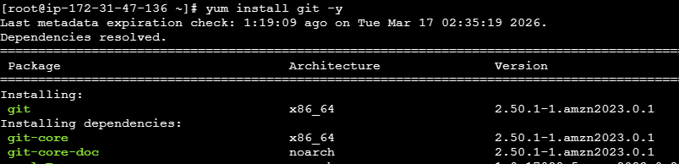
- Switch to user:shriram-surya
git config --global user.name shriram-surya
git config --global user.email sdsuryawanshi0420@gmail.com
- Create directory: private-repo using mkdir private-repo
And then change directory to private-repo by ‘cd private-repo’ then initiate git by ‘git init’
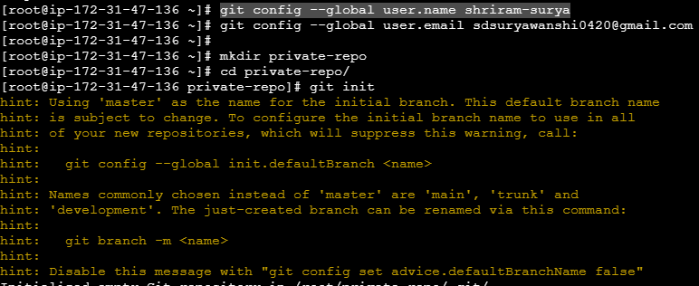
- Now create uat.html and commit into local repository by;
- Vi uat.html --------------Create html file
- git add uat.html ------------------ Add into staging area
- git commit –m “my-script” ---------------- Commit into local repository
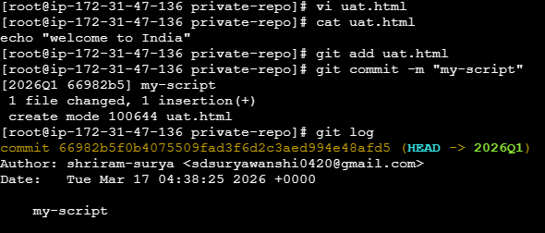
- Create git branch: 2026Q1 using command ‘git branch 2026Q1’ and switch to 2026Q1 by
‘git checkout 2026Q1’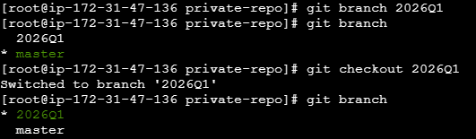

- Now add Git remote repository (private-repo):
git remote add origin https://github.com/shriram-surya/private-repo.git (repository url)
- Now push branch 2026Q1 in git remote repo:
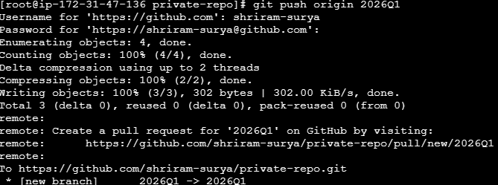
Git push origin 2026Q1
Enter username and password as Git token:
Username: shriram-surya
Password: git token (classic)
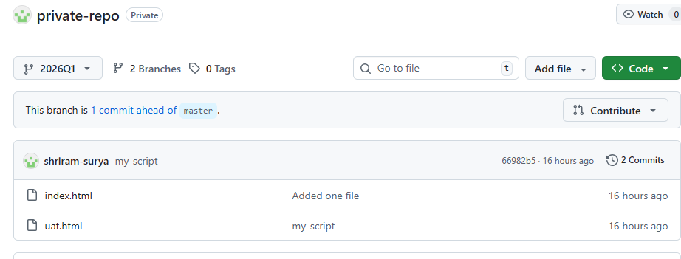

Phase II: Create a jenkins job to deploy code in uat.html (file in git branch 2026Q1) on httpd (/var/www/html)
- Install Java 17 Install tomcat 10download WAR filesetup Jenkins DashboadNow create a job on Jenkins to deploy uat.html on Apache httpd
- Click on “New Create freestyle project with following
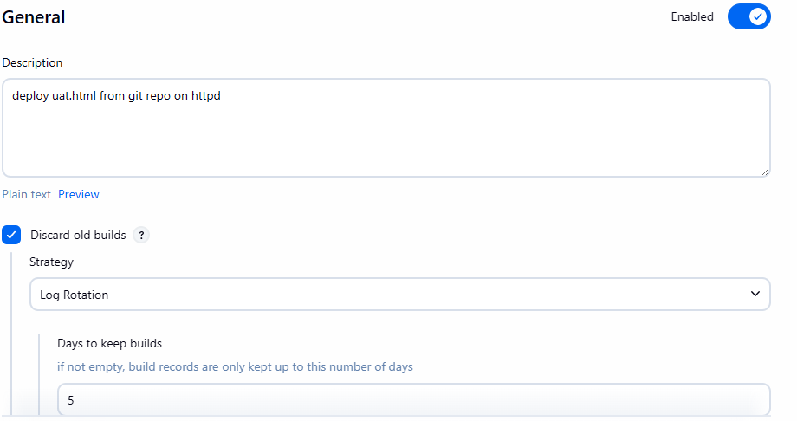
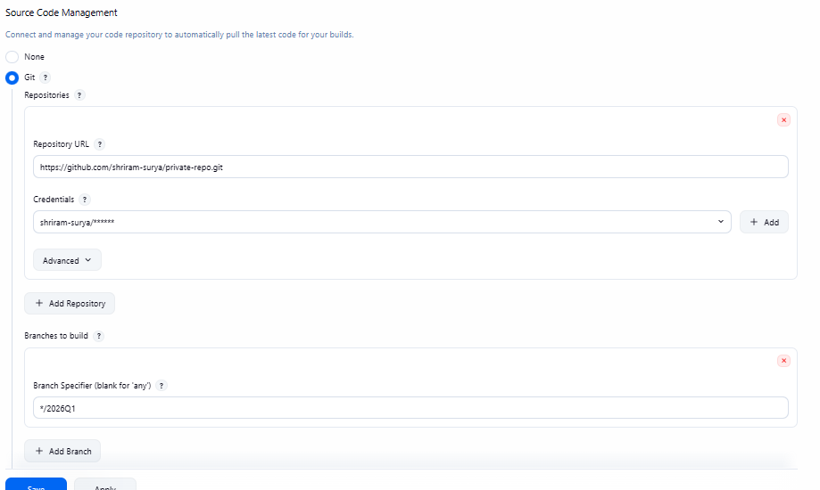

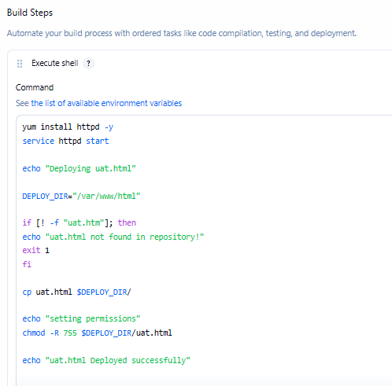
OR
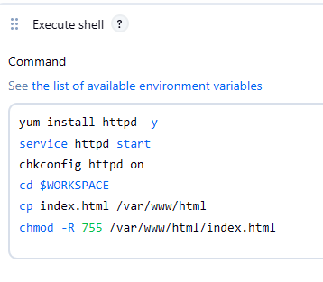

- Now you can save & apply and then buildnow
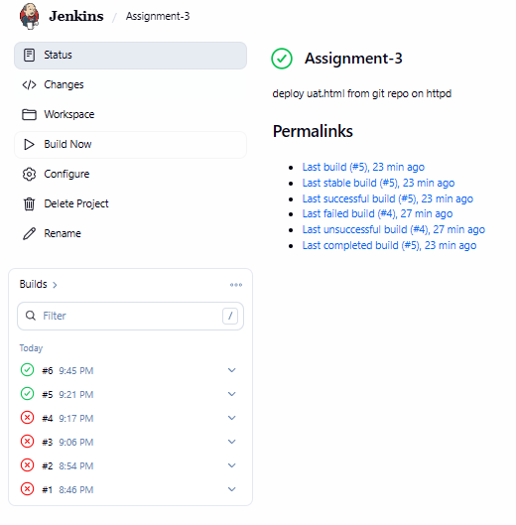
Results:
